UK Ambassador at the Makiling Botanic Gardens
Photo By: AALimpiada
British Ambassador to the Philippines H.E. Laure Beaufils visited one of the attractions at the Mount Makiling Forest Reserve ASEAN Heritage Park which is the Makiling Botanical Gardens today 08 November 2022. The Ambassador had a quick tour inside the gardens before visiting the ASEAN Centre for Biodiversity. Dr. Rogelio T. Andrada II, Deputy Director of the Makiling Center for Mountain Ecosystems led the tour up to the Molawin Creek.

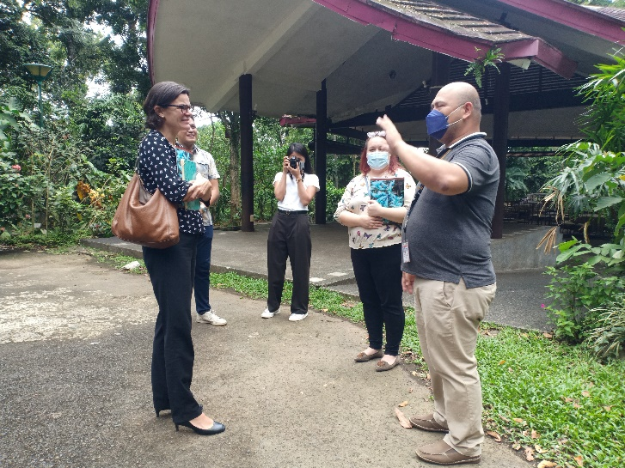
Brief introduction of the Mount Makiling Forest Reserve
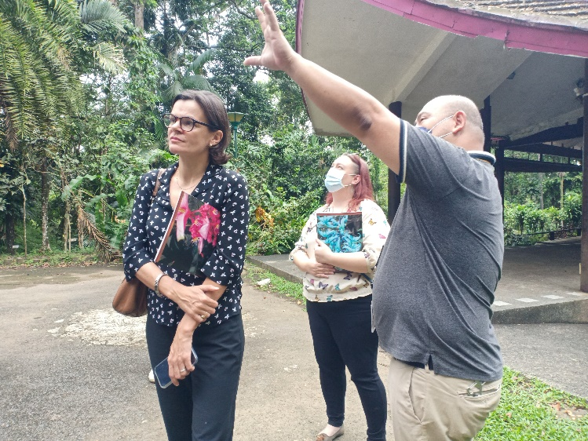
Discussing the Dipterocarps

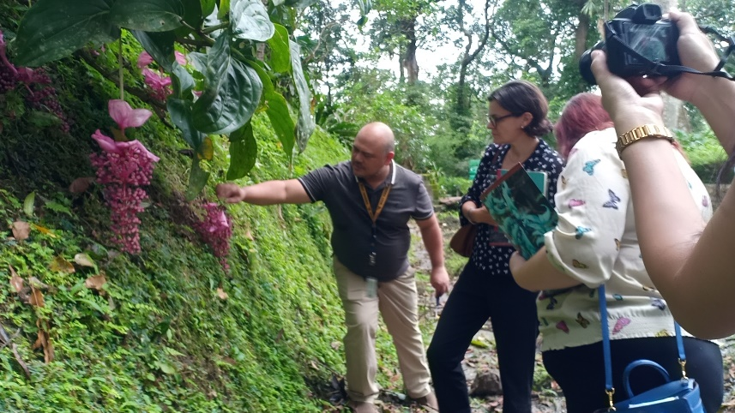
Showing the Medinilla magnifica Lindl. as banner species of MBG
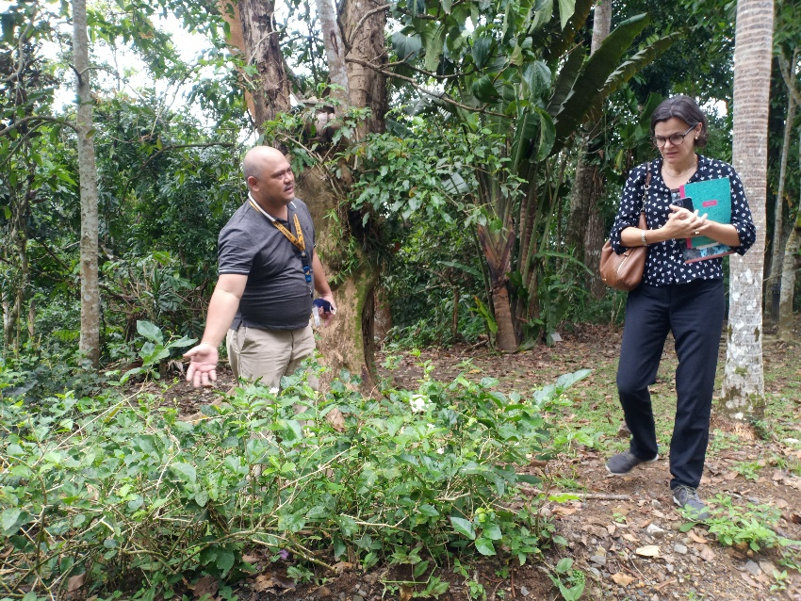
Showing the Sampaguita as the Philippines’ National Flower
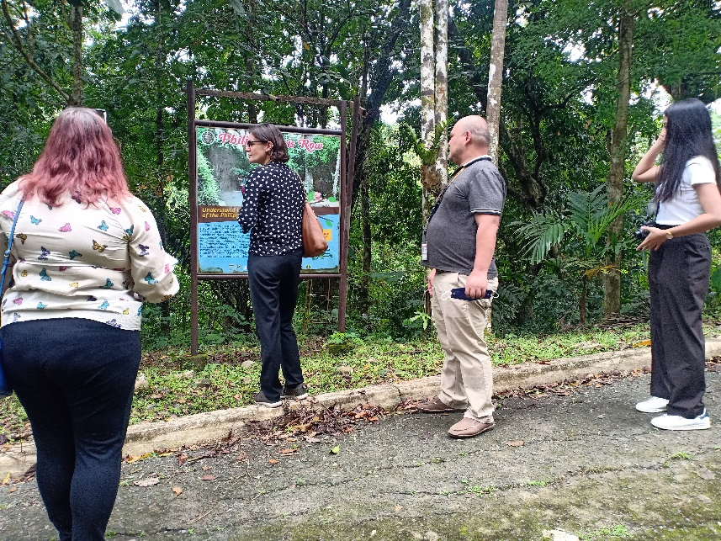
Tour at the Philippinensis Row
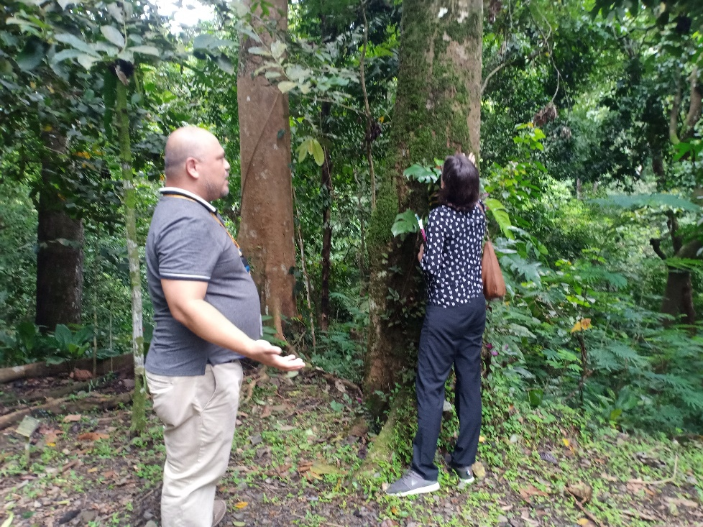
Talking about the amazing Ilang-ilang

